AWS PRACTICE
https://www.tutorialspoint.com/amazon_web_services/index.htm
AWSAmazon Web Services.
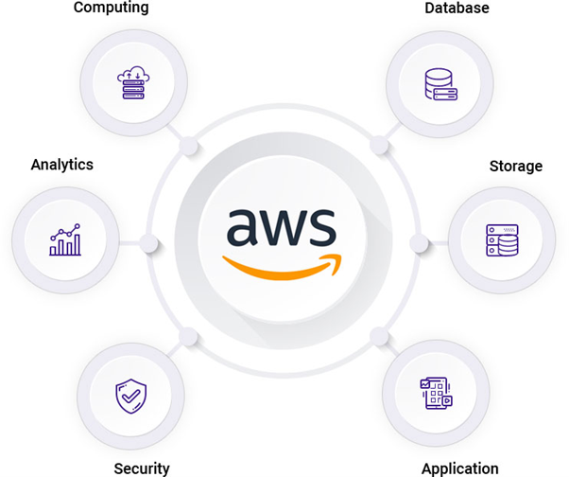
Amazon Web Services (AWS) is Amazon's cloud computing platform, offering on-demand IT services like compute power, storage, databases, and machine learning, accessed over the internet.
Types of Cloud Computing:
Cloud computing offers different types of services (IaaS, PaaS, SaaS) and deployment models (public, private, hybrid, and multi cloud).
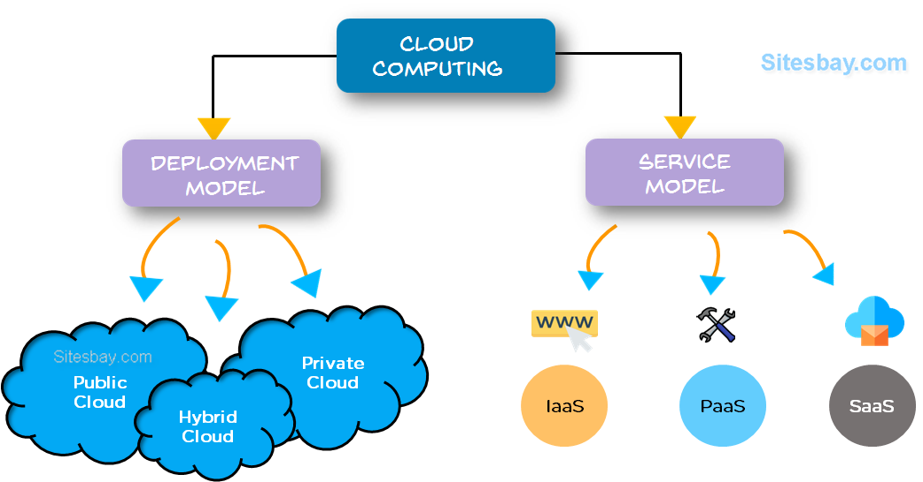
Cloud Deployment Models:
These are the different ways cloud resources are deployed:
Public Cloud: Services are owned and run by a third-party provider and delivered over the internet to multiple customers.
Private Cloud: Infrastructure is built and used by a single organization, often located on-premises or by a dedicated provider.
Hybrid Cloud: A combination of public and private clouds, allowing data and applications to be shared between them.
Multicloud: Using multiple public cloud services from different providers.

Cloud Service Models:
These are different levels of managed services offered by a cloud provider:
Infrastructure as a Service (IaaS): Provides virtualized computing resources like servers, storage, and networking over the internet.
Platform as a Service (PaaS):Offers a platform that allows customers to develop, run, and manage applications without the complexity of managing the underlying infrastructure.
Software as a Service (SaaS): Delivers ready-to-use software applications over the internet, such as email or file-sharing services, on a subscription basis.
EC2 - Introduction:
EC2 Stands for Amazon Elastic Compute Cloud.
In AWS we call it as EC2 but in general language we call as Virtual Machine.
Virtual MachineIn general language it is a computer, but it does not physically exist. It is virtually created somewhere in AWS.
Creation of EC2- Machine in AWS Account:
First Select Region. Means From where you are going to use
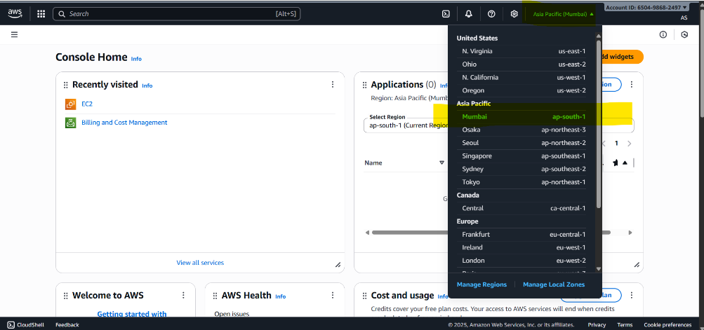
Select EC2 Service Search EC2 in AWS account. It will have a tag line Virtual service in cloud.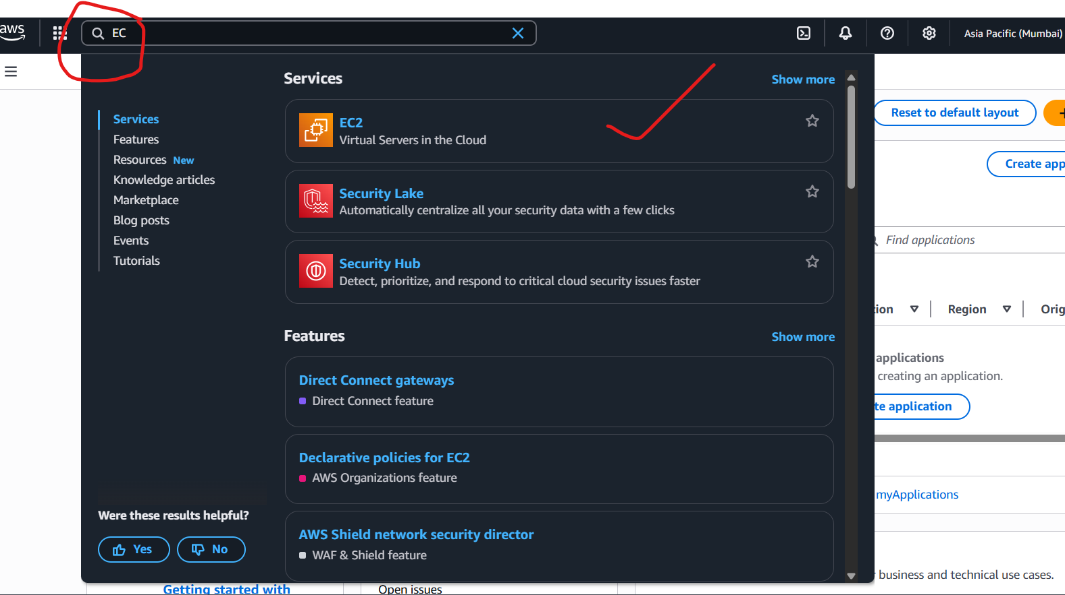

Click on Lauch instances.
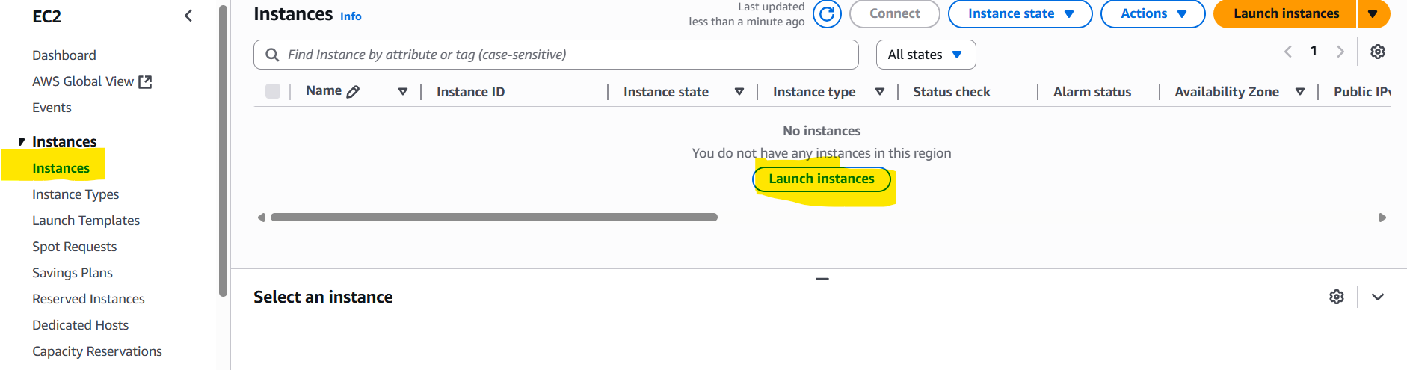
Step-1: Enter the Name.
Step-2: Select the Operating System. I’m selecting the Amazon Linux.
Step-3: Choose Amazon Machine Image (AMI)Select free eligible to work for free without paying money.
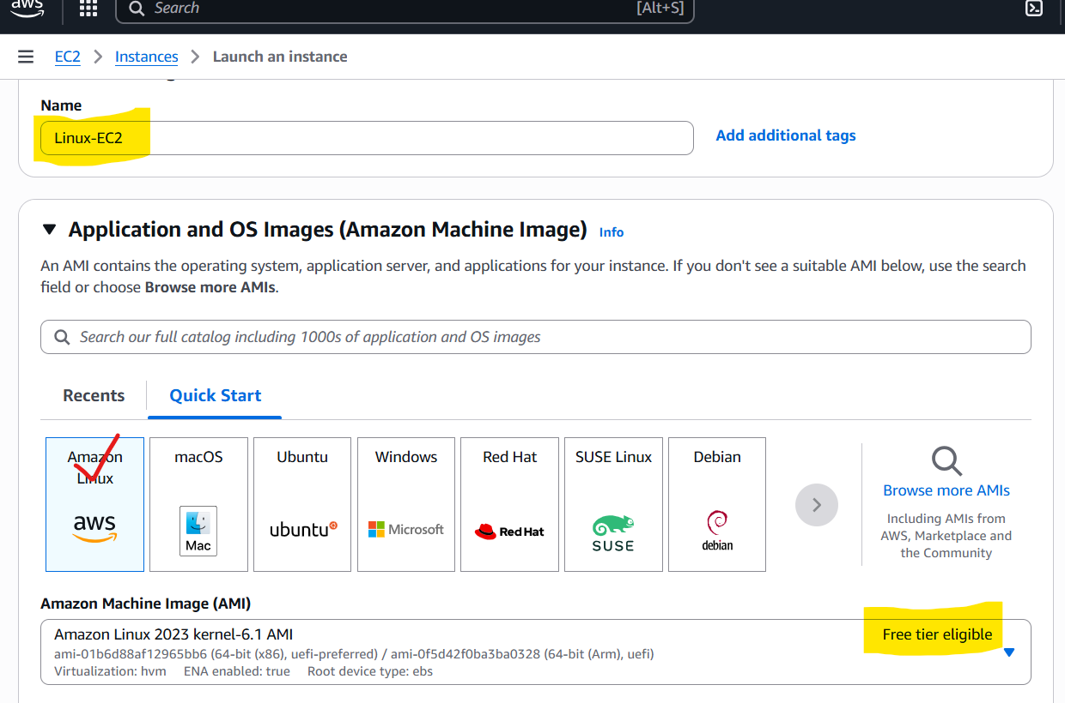
Step-4: Create Key-pair.
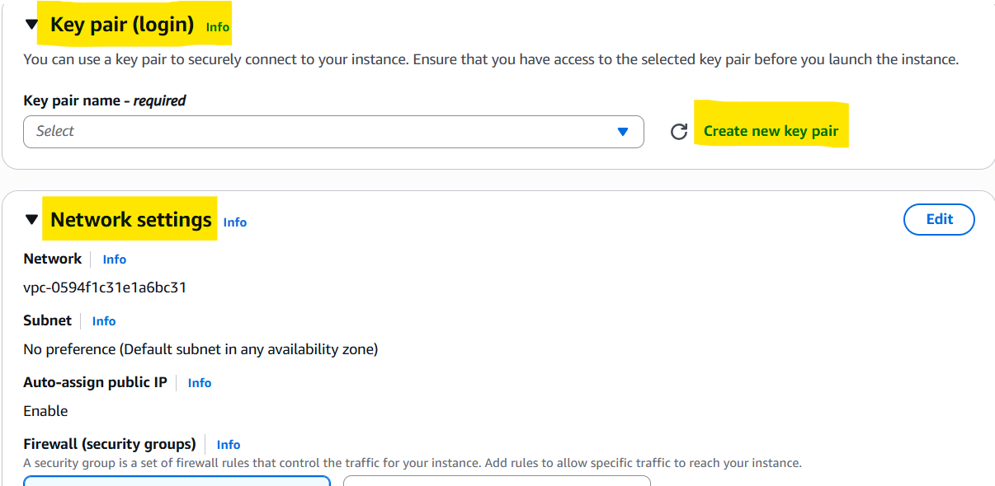
And we are not changing any Network Settings. We are going to use default settings only.
If we want to change the Security group name. We can declare any name instead of launch-wizard. It is our wish to change the name.
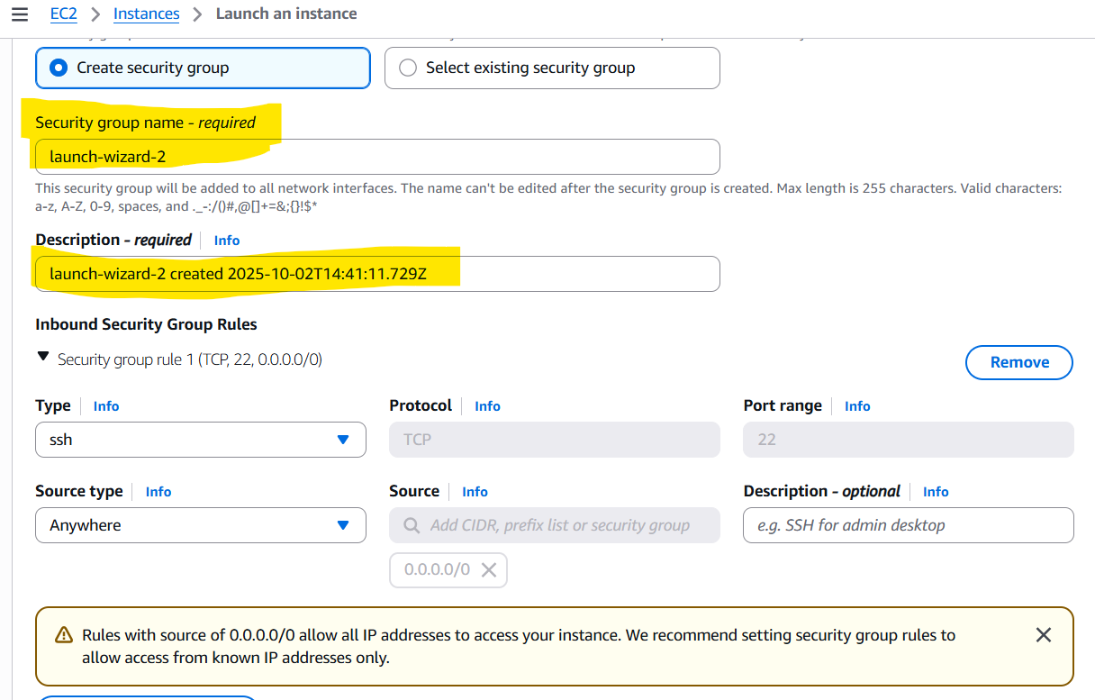
After checking all options. In Right side there is summary to check the options what we are choose. In that we have number of instances means number of EC-2 Machines just select it and later just click on Lauch instance.
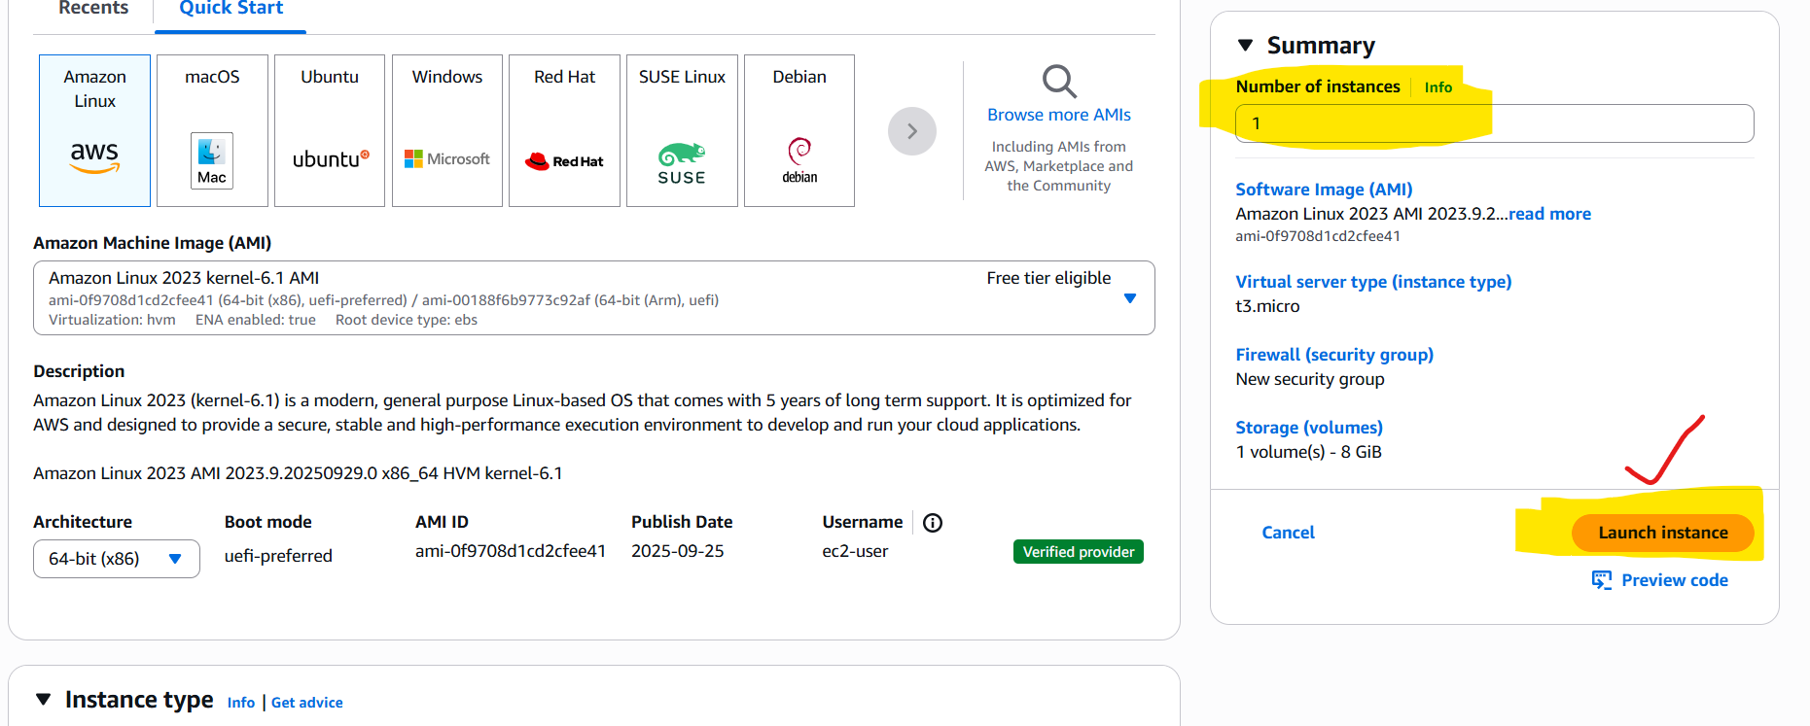
*…………………………….In this way we are going to create EC-2 Machine……………………………….*
To connect EC-2 machine to windows we are going to use RDP (Remote Desktop Portal). For Linux we are going to use Putty and Puttygen.
Why I’m using putty? Because as per current situation in market putty is No:1 in the market.
Putty | puttygen
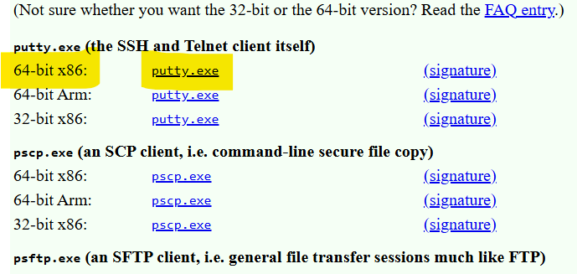 | 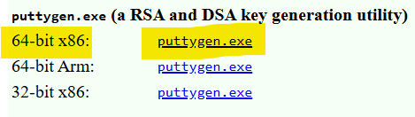
Before downloading check, the requirement of the system what to download, I’m installing 64-bit because nowadays most of the systems are 64-bit so download the 64-bit.
Why we download putty? Because to convert .pem file into .ppk file.
pem privacy enhanced mail.
ppk PuTTY Private Key.
Why should we convert? Because putty doesn’t support pem file. We must convert pem to ppk file.
RSA stands for Rivest, Shamir, Adleman algorithm
Connecting Linux machine: Double click on Puttygen and open Puttygen.
- Click on load.
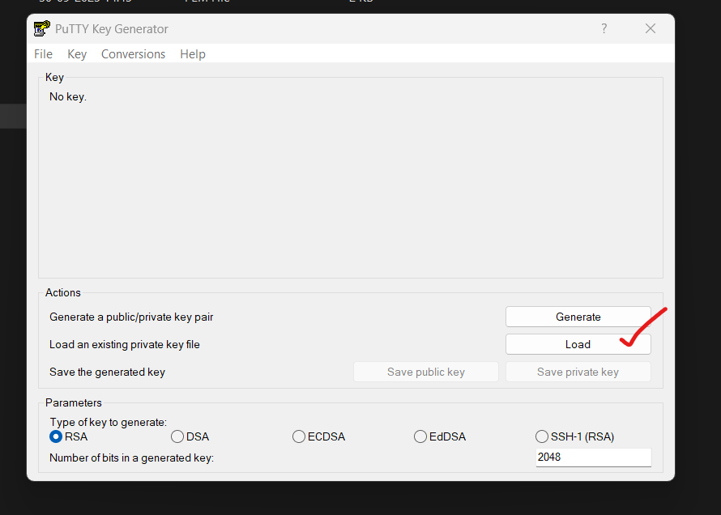
In folder we cannot see any files if we are in PPK option, then we change option to all files we can see all files then we want to select PEM file.
In folder we can’t see PEM file | To see PEM file change option into All files
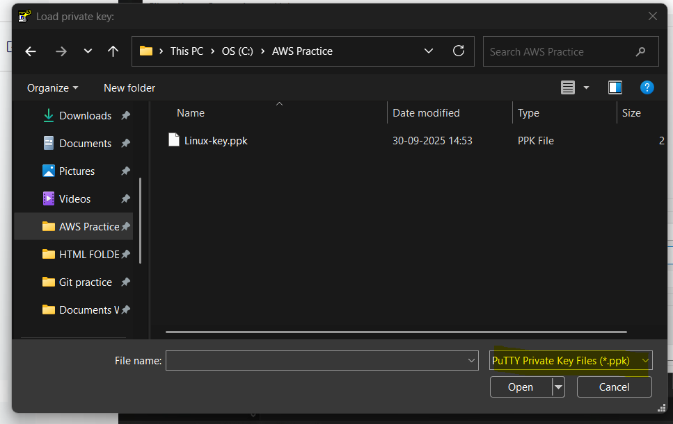 | 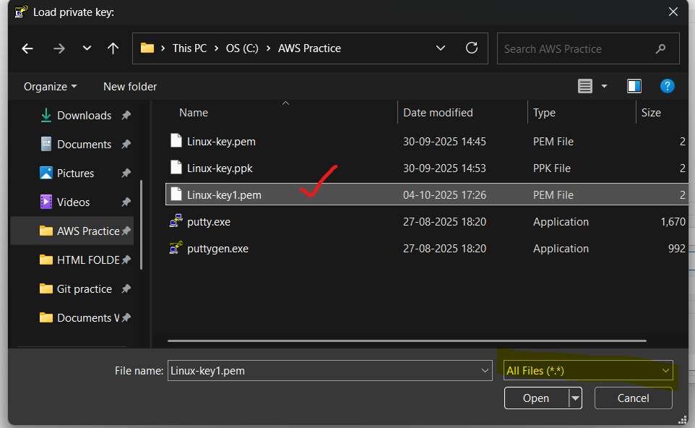

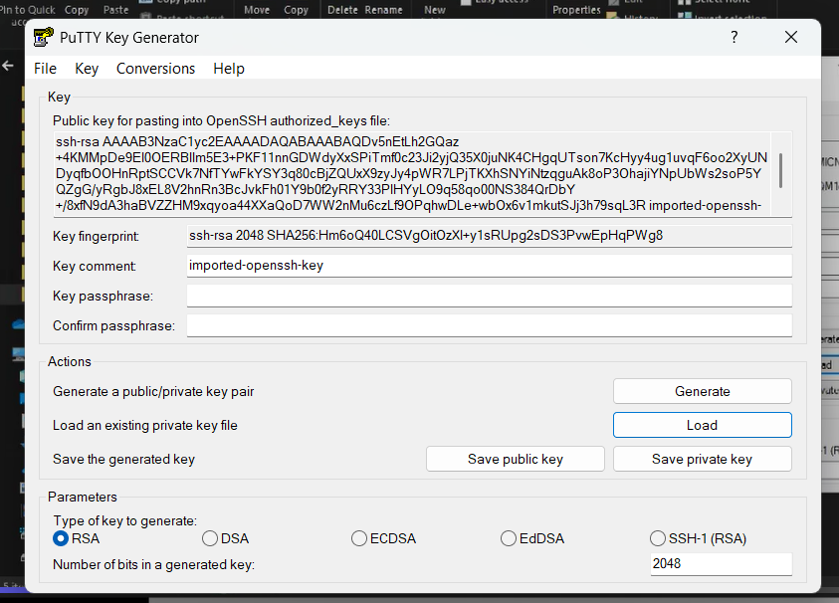
Step-1 is Completed, we have loaded our PEM file.
Then click on Save private key and click yes to Generate PPK file.
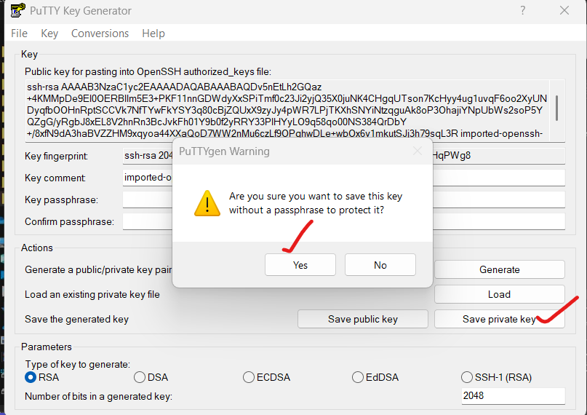

Give the name to the PPK file and save it. I’m giving the Linux-key1.
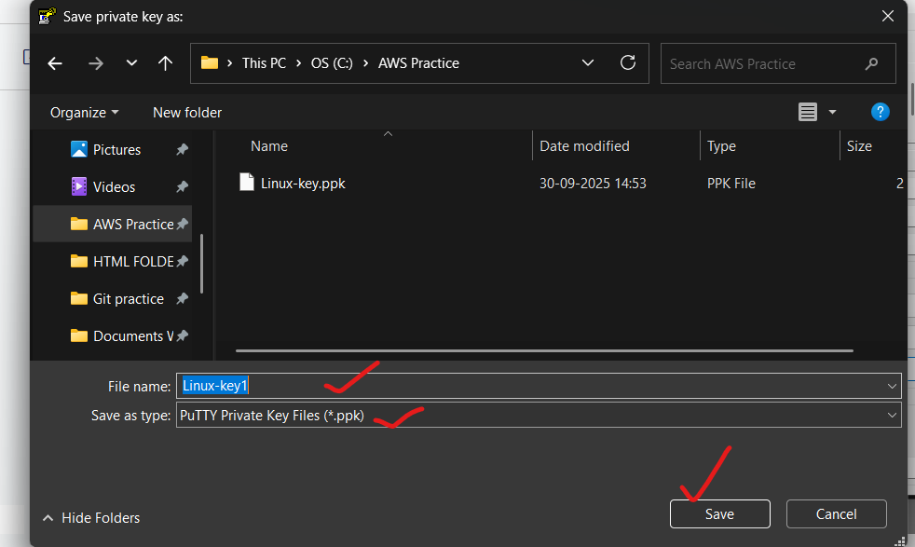
In selected folder PPK file is kept.
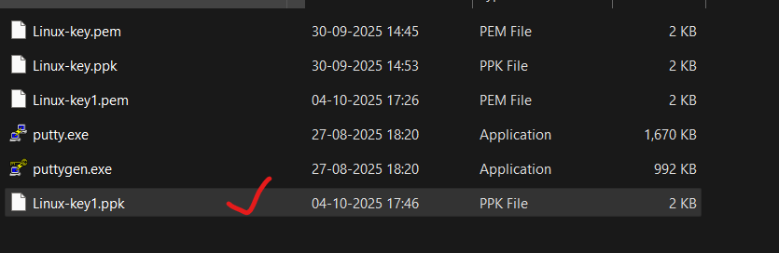
Generating PPK is very important step. Without creating PPK file, we cannot connect with our Linux machine.
How to connect putty and EC-2 machine.?
Now, select the EC-2 machine and click on connect.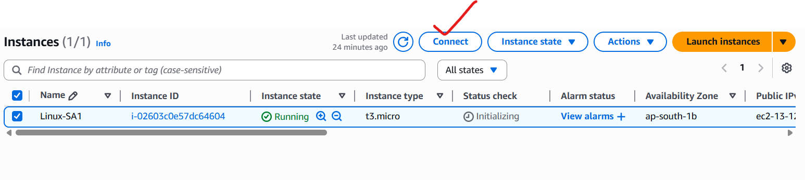
And go to SSH client tab and note down the Host name. Host name is start from ec-2 user and select for till last.
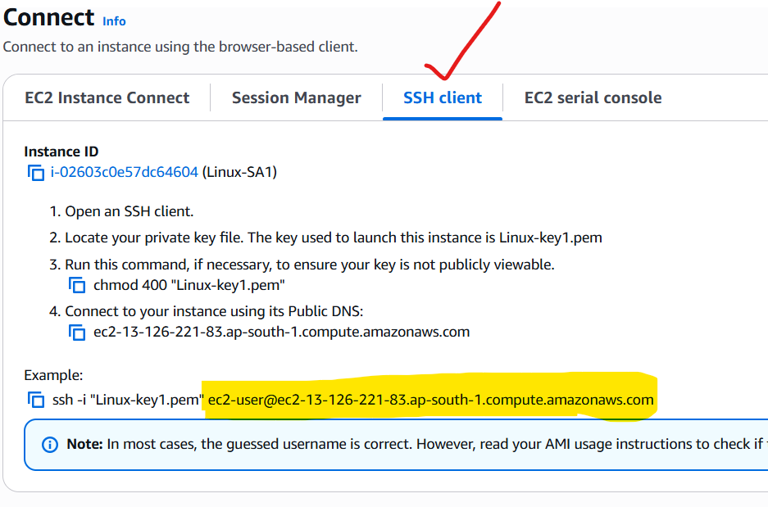
And now, open the putty. Enter the Host name.
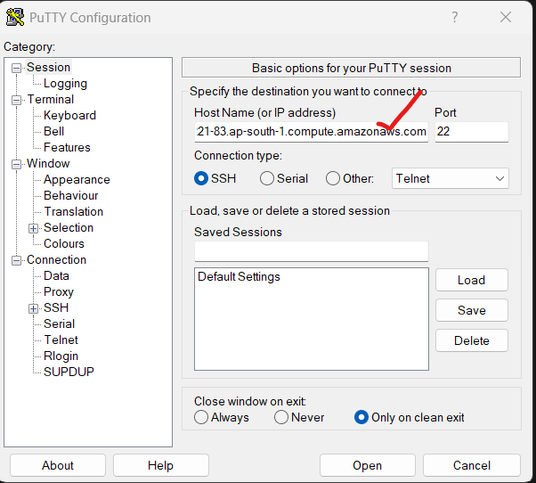
And attach PPK file with putty. To attach PPK file with putty, click on + button SSH, and next click on + button Auth, and click on credentials, in Private key file option Select our PPK file. Click open.
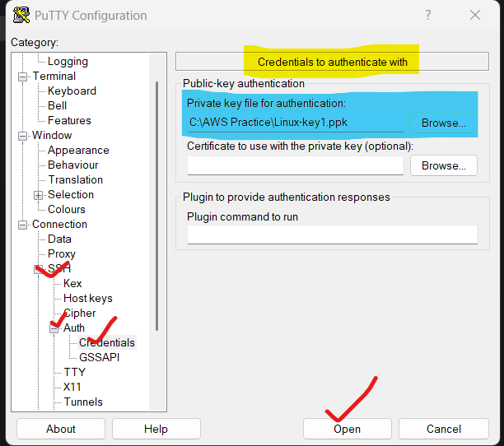
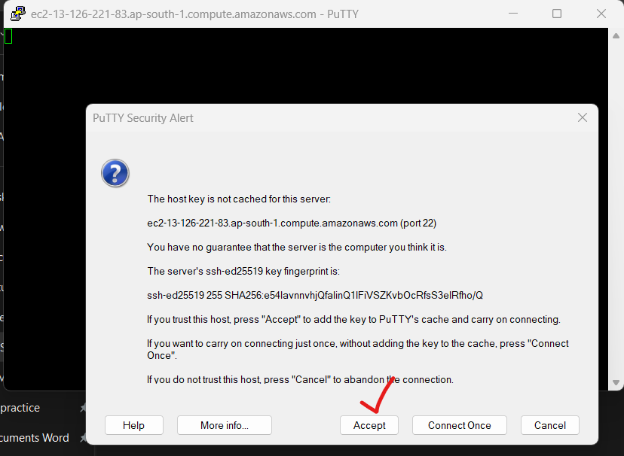
And click on Accept. And we are going to connect with Linux EC-2 Machine.
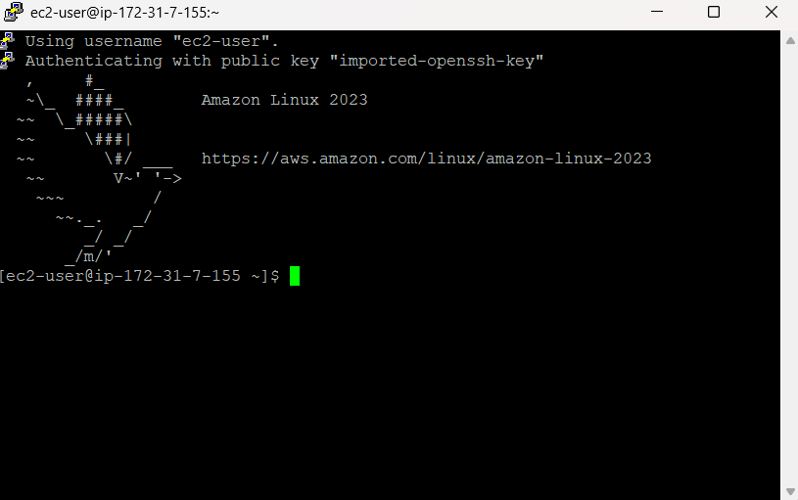
We relate to our Linux CE-2 machine. Here by default username will be come.

We can connect EC-2 machine with Ip-address also. Here we can see the Username of our ec-2 machine.
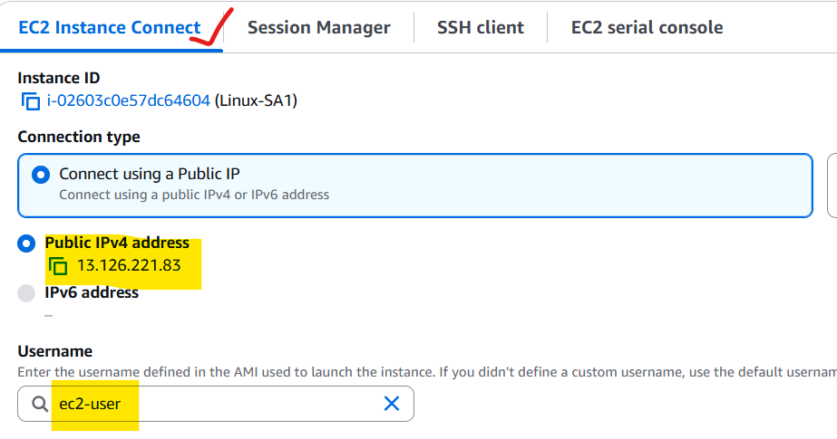
click on + button SSH, and next click on + button Auth, and click on credentials, in Private key file option Select our PPK file. Click open.
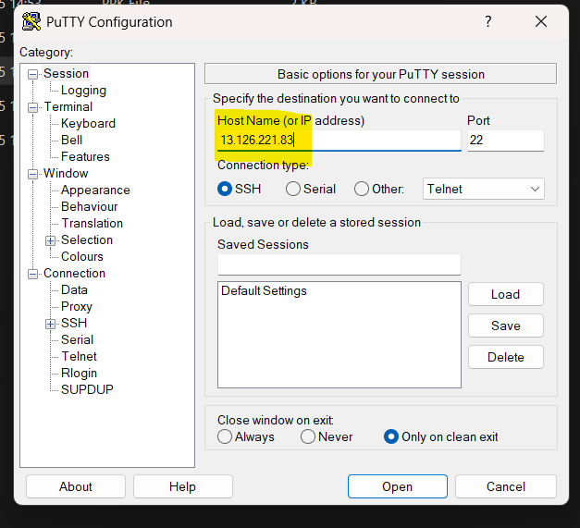

Here we want to enter our username, by default every ec-2 machine has their default username.
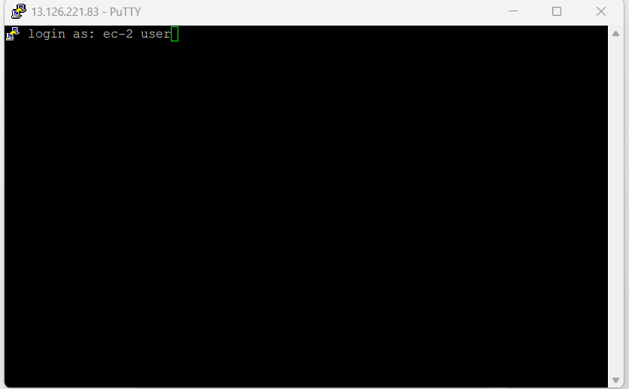
Through IP-address also we can connect our EC-2 machine. But we want to enter the username.
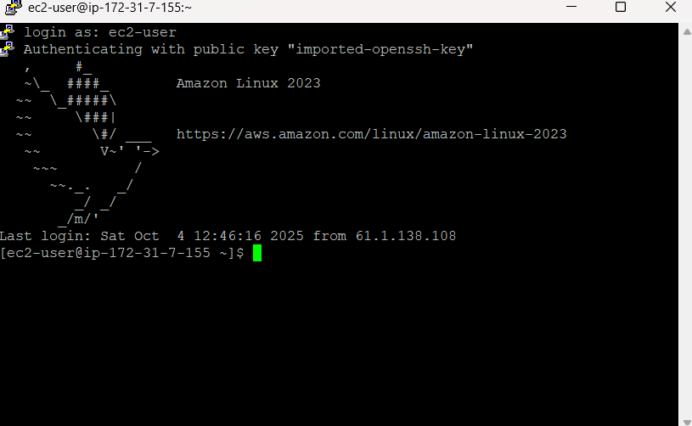
Completing work with ec-2 machine, we must terminate the ec-2 machine. If we are not terminating the machine, it charges the fees.
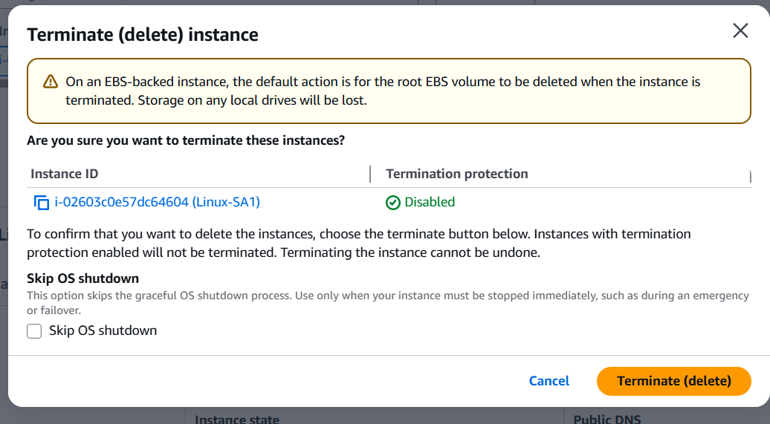
....In these ways we can create EC-2 Machine...!

DAY-2 LINUX COMMANDS

Step-1: To Learn Linux Commands, create Amazon EC-2 Machine.
Step-2: Connect to the EC-2 Machine.

How to create a file in Linux Machine? There are multiple ways to create a file in Linux Machine.
1st-approach: create a file through the command. The command is cat > <file_name> with help of cat command we can create a file. Here is the name of the file we can give any name.
After creating file press Enter. After pressing Enter we can write text on it whatever we are going to save in the file. To save and exit this file we must press ctrl + d. In this way we can create a file with name aws.
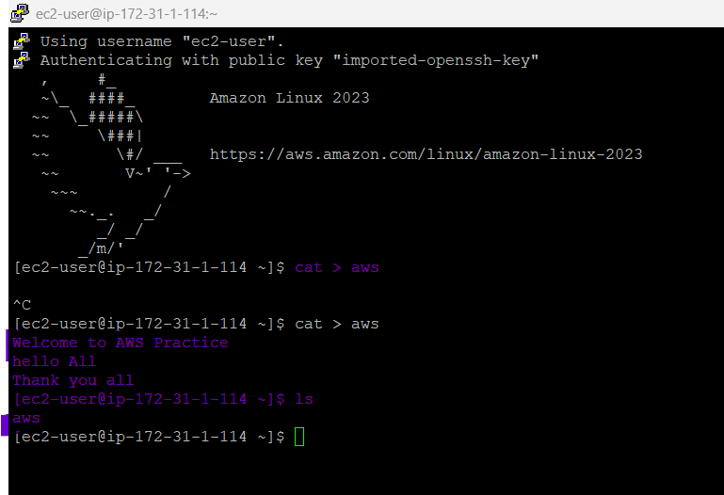
How can we see that file? To see the file, we have a command called ls. ls means list. With the help of ls command in the current location, we can see all the files and folders also.

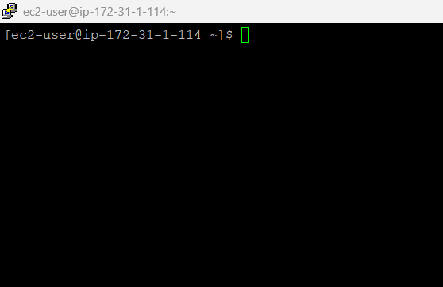
Whatever the text written in terminal. To clear the terminal, we use command the command is clear.
How do I read the file? To read the file we use same cat command only. The command is cat <file_name> (cat aws). But without greater than symbol (>).
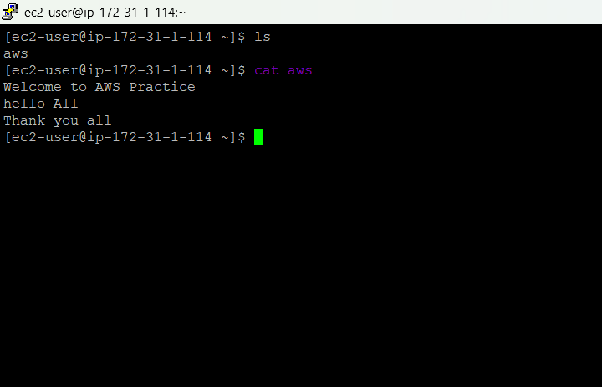
By using cat command, we can create the file, see the file and read the file also.

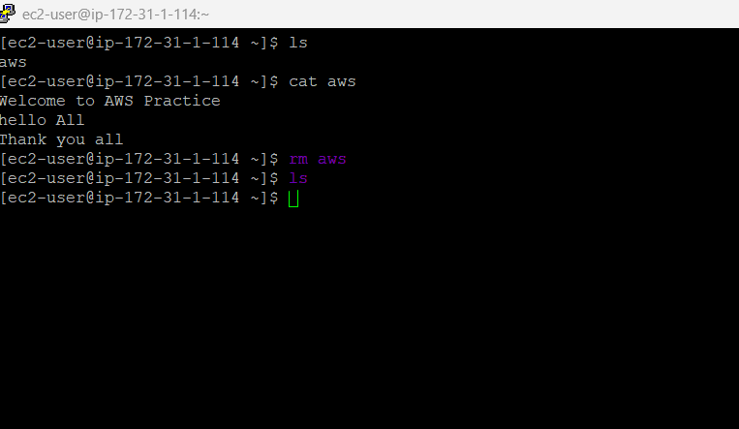
Next, I want to delete or remove the file For the delete or remove the file we use rm <file_name> (rm aws). Here, rm means remove.
After using it we can delete the file, and we use ls to see the list of files, but there is no file is theirs. Because our file is already removed.

How do I create a folder or directory? Both are same. But in windows we call it folder. In Linux we call it directory.

How can we create directory in Linux? We use the command,
mkdir <Directory_Name> (mkdir devops).mkdir means make directory.
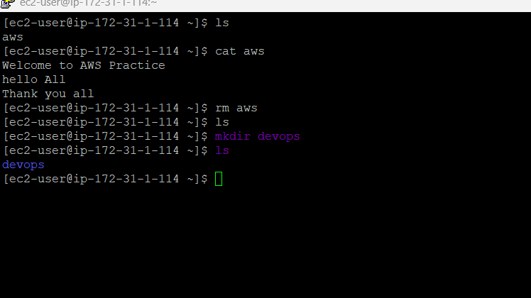
How to check the current path? We use the command pwd. Here pwd means as per old Linux books it is present working directory. And as per new Linux books it is Print working directory. It will show current location of my cursor.
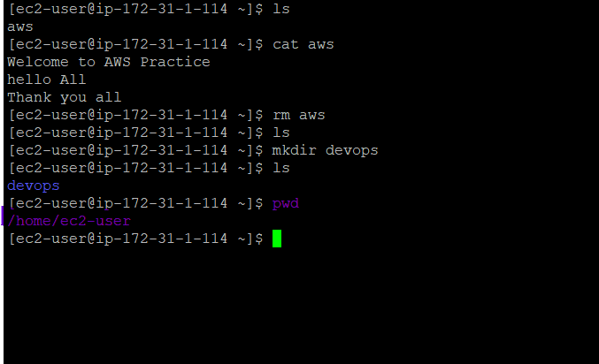
Now, I want to go to my devops directory. For going inside devops directory we make use of command cd <Directory_Name> (cd devops). Here, cd means change directory.
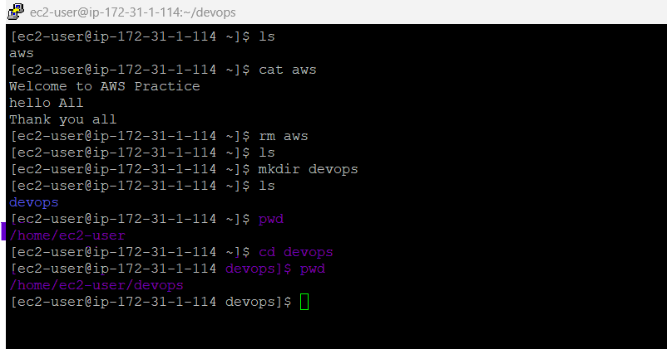
Earlier it showed /home/ec2-user and now it is showing /home/ec2-user/devops. Because we are in devops directory.
If we want to go for previous directory we make the use of cd .. command. With the help of cd .. it will go back to one of the previous location or directory. Here we see the present location path is /home/ec2-user/devops. After using the command, we see the path /home/ec2-user. And if we are in second or more than one hundred directories then we want to come to user we want use command cd. It will come to user location by this command.
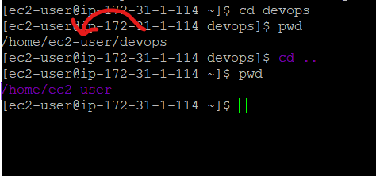
Next, I want to delete the directory. To delete this directory, we have the command is rmdir <Directory_Name> (rmdir devops). But if we run the command, we get errors. We cannot delete the directory by using this command because we have text in that directory.
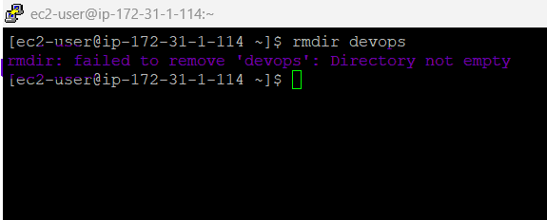
We use another command to delete the directory. The command is rm -r <Directory_Name> (rm -r devops). Here, -r stands for recursive. rm -r: Removes directories and their contents recursively(repeatedly).
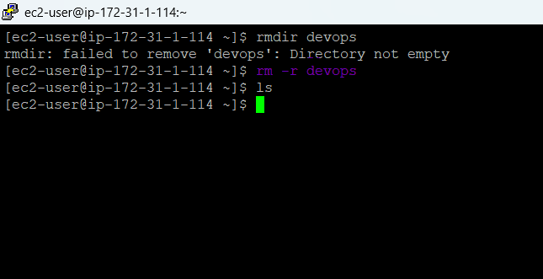
How can we identify File and Directory? We know what the file and directory are and here in we have color variation aws is file and d1 is directory. In later update we have same color then how can we identify? We use the command ls -l, we can see -rw-r--r-- it is for file. And drwxt-r-xr-x for directory. Directory starts with d. In this we can identify.
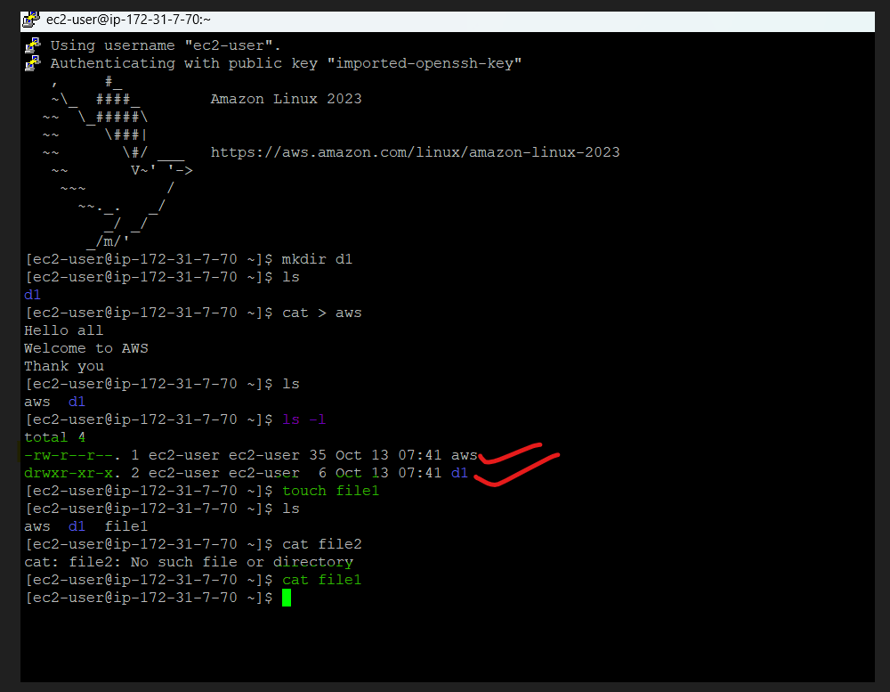
We can create a file with the use of touch <file_name> or cat <file_name> command also. But using touch command we cannot store content on this file. It used for empty file creation.
How to hide the files and directories? For this we can use touch and cat command for file. And mkdir for directory. But there is a slight change when we create a file and put a directory into it . (pull stop) Infront of the file name and directory name.

Example: touch .<file_name> or cat .<file_name> to hide empty files. To hide content and file we use cat > .<file_name>.
These commands we can see below.
By using ls and ls -l also we cannot see the hidden files and directories.
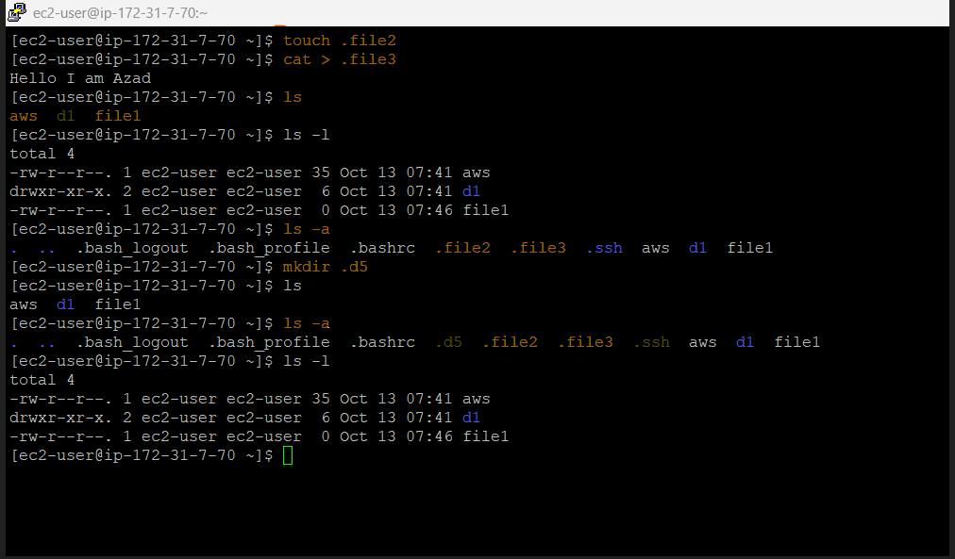
How can we see the hidden files and directories? To see the hidden files and directories we use the command ls -a. Means lists all files and directories, including hidden ones, within the current directory. By using this command here we see our hidden files and directories which were created.

The combination of ls -l and ls -a, they created two commands which we can see the hidden files. Those commands are ls -al and ls -la. Here, .ssh is a hidden directory.
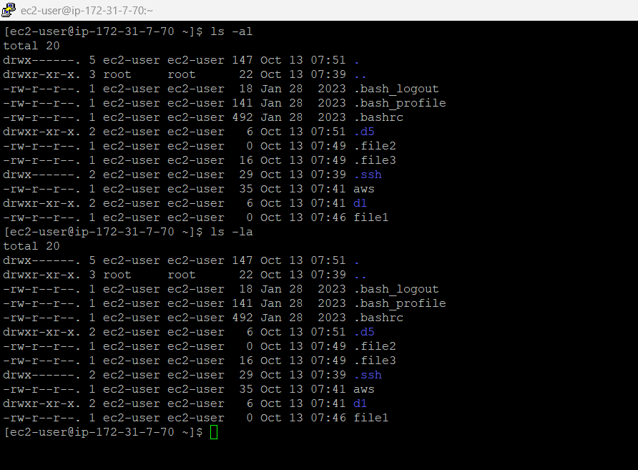
How to create copy of a file? To copy a file just we use the simple command is cp <Source_file_name> <Destination_file_name>. Here I am using source file as aws and destination file as azure. We can see the copied file. We use cat azure command to see the content of azure. we see same content of aws. Because azure is copied file of aws.
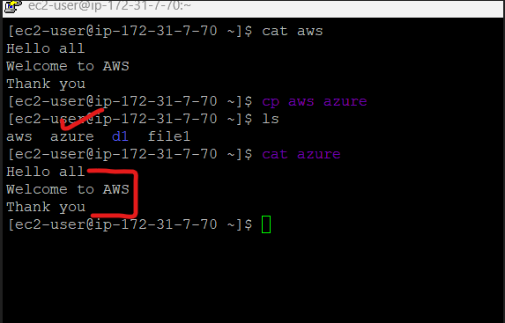

How to see user we are connected ? we use whoami command.
With the help of ls -lt we can see the list of files according to timestamp. It shows new files on top and old file on bottom.
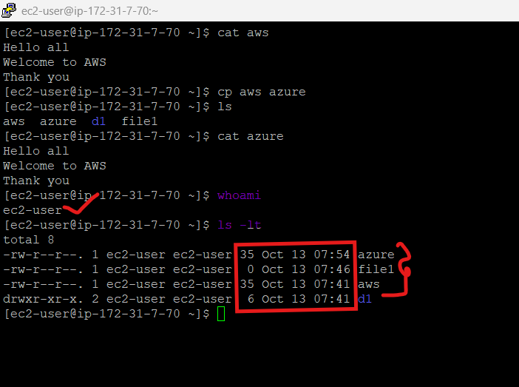
What is difference between $ and #:
- Dollar Sign ($) means you are a normal user.
- Hash (#) means you are the system administrator(root).
By default, we are normal users. To change normal user to root user we use su root by using this command it may ask password, but do not know the password.
The 2nd Approach is sudo su root. sudo stands for “super user do” . In Linux we use sudo command. But windows we have Run as administrator.
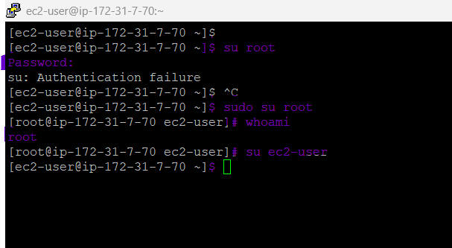
**After sudo su root command the ec2-user($) changed into root(#).**
To see the current user, we use whoami command.
**To change root user to ec2-user we use su ec2-user command. **

By using, date command we can see the current time, date, month, year also. But these are not current details of our region, they are server timings. AWS uses same time zones for all the regions. With help of this same time-zone they can easily manage their service.
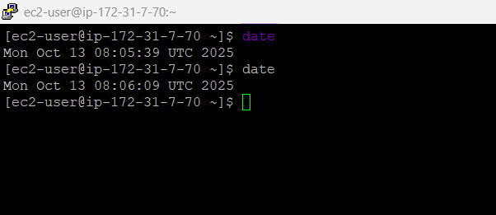

DAY-3 LINUX COMMANDS

https://www.google.com/search?q=what+is+permissions+in+linux&oq=what+is+permissions+in+li&gs_lcrp=EgZjaHJvbWUqCAgBEAAYFhgeMgYIABBFGDkyCAgBEAAYFhgeMggIAhAAGBYYHjIICAMQABgWGB4yCAgEEAAYFhgeMggIBRAAGBYYHjIICAYQABgWGB4yCAgHEAAYFhgeMggICBAAGBYYHjIICAkQABgWGB7SAQoxNzQ0N2owajE1qAIIsAIB8QW_vL2eHHN7vg&sourceid=chrome&ie=UTF-8
Linux permissions are important in Linux.
Linux permissions determine who can access and modify files, directories, and other system resources. These permissions are assigned to each file or directory and are based on three categories:
- Owner: The user who owns the file or directory.
- Group: A group of users assigned to the file or directory.
- Others (World): All other users on the system.
For each of these categories, three basic permission types exist: RWX(Read, Write, Execute).
- Read (r): Allows viewing file contents or listing directory contents. Read represents number (4).
- Write (w): Allows modifying file contents or creating/deleting files within a directory. Write represents number (2).
- Execute (x): Allows running a file as a program or accessing a directory. Execute represents number (1).
We have RWX and Numbers also.

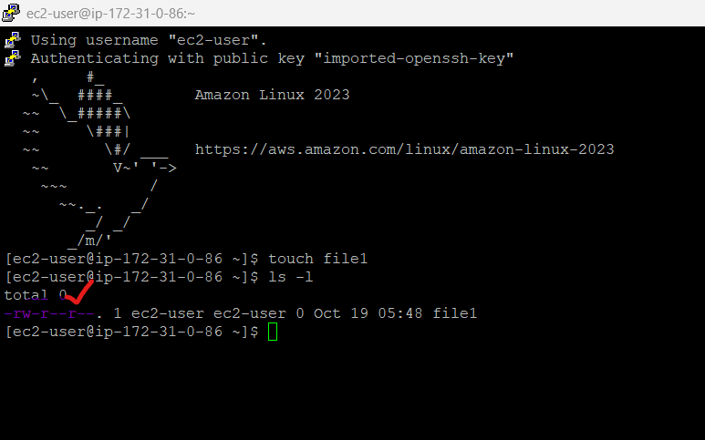

What is the use of RWX and Numbers? Based on this we can give permissions to file and directory.

How to change the file Permission? With help of chmod(change mode) command to change the change the permission.

To change the permission, we have two ways:
1. Absolute Mode (Numerical).
2. Symbolic Mode (Alphabets).

Based on these two options we can change the permissions. It’s our wish to use which option is easy to us. There are no restrictions in Linux to use Particular mode (OPTIONAL).

Absolute Mode (Numerical).
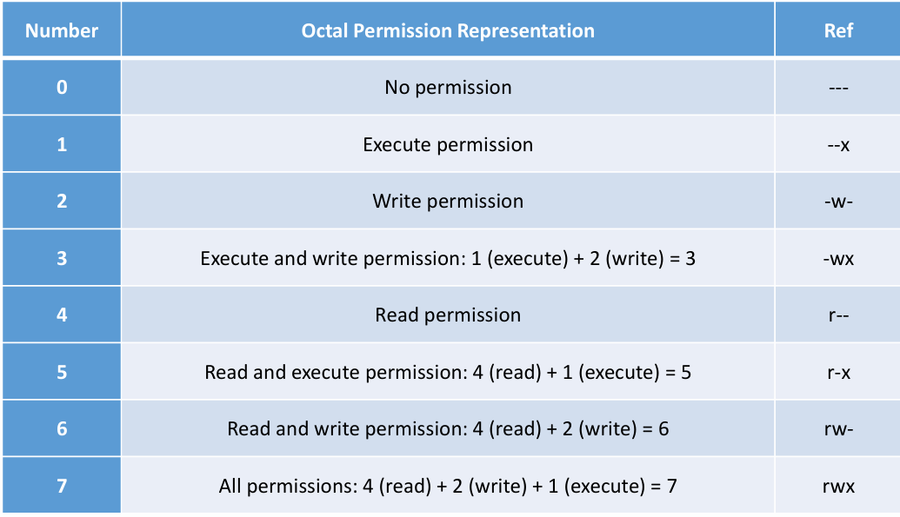
In Absolute Mode we must remember 8 Numbers in this mode. With these numbers we can change and give permissions.

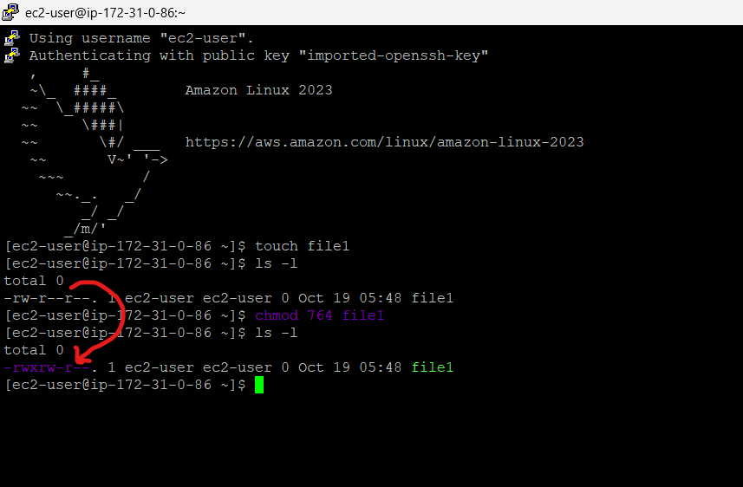
Before giving the command, we have: rw- at Owner level we have these permissions.
: r-- at Group level we have these permissions.
: r-- at Others level we have these permissions.
Applying the command to change the permissions for Owner, Group, Others level. The command is chmod 764 file1 or chmod 764 <file_name> .
After applying the command, we have: rwx at Owner level we have these permissions.
: rw- at Group level we have these permissions.
: r-- at Others level we have these permissions.

In this way we can change permissions, based on our requirements. We can give read, write and execute permissions for owner, Group and Others level also.

Chmod 777 file1 | Chmod 444 file1
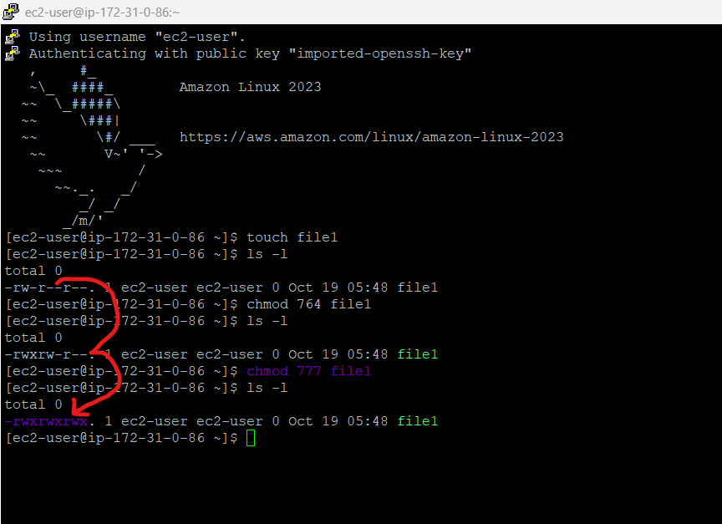 | 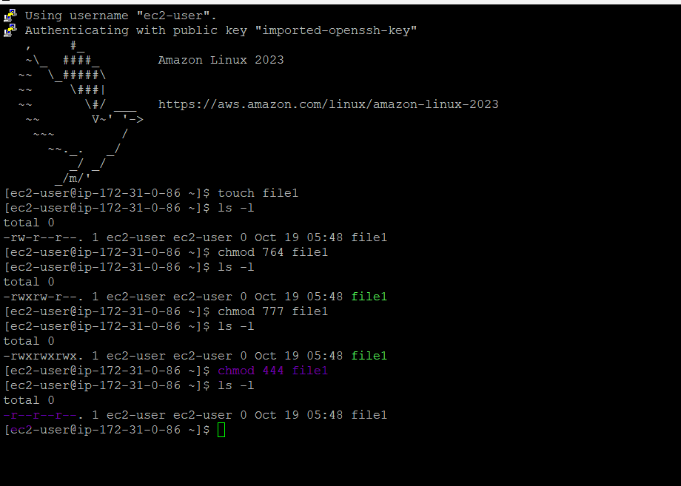

Here I am using chmod 777 file1 command for giving permissions for all levels. For all level permissions we use 777.
And im using chmod 444 file1 command for reading permission for all levels.

Symbolic Mode (Alphabets):
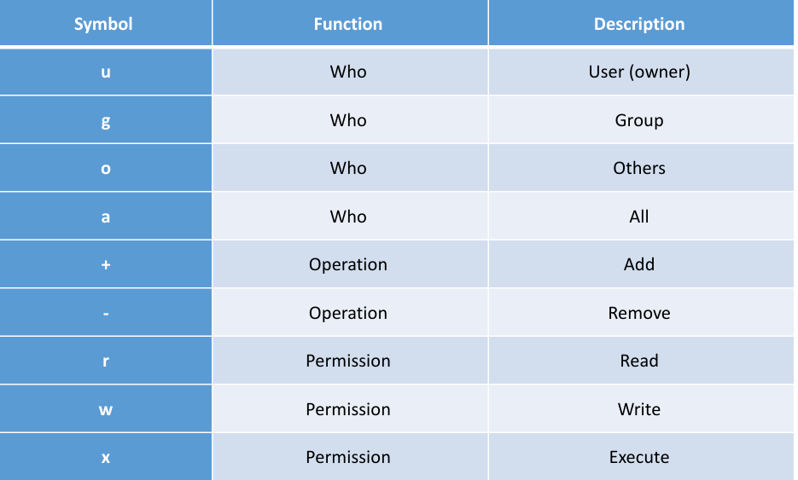

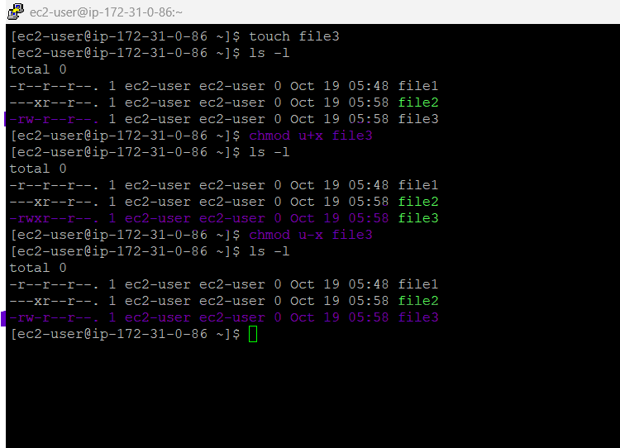
For add the permissions we use + operator. The chmod u+x file3 is u used for user(owner) and adding (+) the x (execute). After this command we give the rwx permission in owner level.
To remove the permission, we use – operator. The chmod u-x file3 for remove the permission.
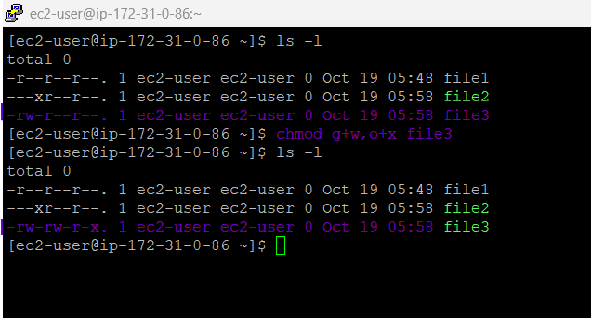
By comma (,) separated we can provide multiple permission at multiple level. Her I am using chmod g+w,o+x file3 command for multiple permissions at multiple levels.
Based on requirements we can change the permission of file or directory. By using alphabets or numbers.

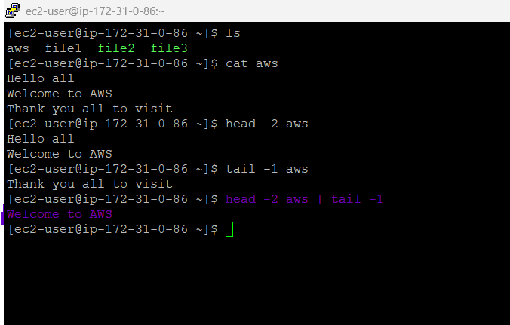
Here I’m created one file is aws. I am using cat command to write some text in that file. After creating file to see the first two lines we use head -2 <file_name> and for last line we use tail -1 <file_name> commands.
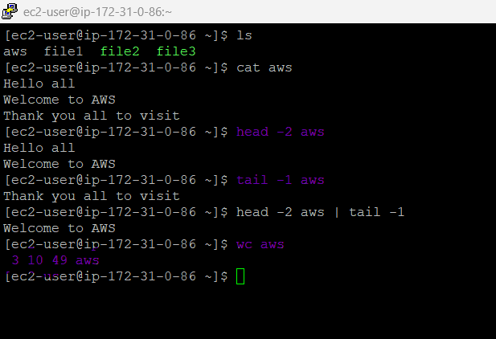
Here I am giving two commands using pipe symbol (|). Whenever we are using pipe symbol the LEFT-hand side command (head -2 aws) will execute first and RIGHT-hand side command (tail -1 aws) will execute.
RIGHT hand side command executes from the after executing the LEFT-hand side command.
wc <file_name> command will display the no.of lines, no.of words, no.of bytes and filename from the file. Here in aws we have three lines (3), ten words(10), size in bytes (49) and filename(aws).

YUM REPOSITORY:
• An YUM Repository is a collection of packages. YUM Repository allows you to perform package install, removal, upgrade operations on individual packages.
• In Red hat also, it is called YUM Repository & in Ubuntu is called as APT Repository

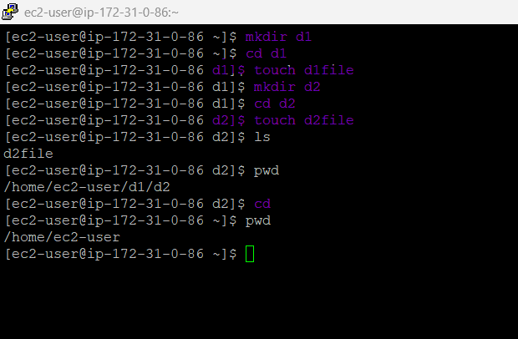
We can use the directory which we have created in the above example.
When you use the TREE command each directory name is displayed along with the names of any subdirectories within it. Command is not working.
To work with this command. We must install the packages from YUM repository.
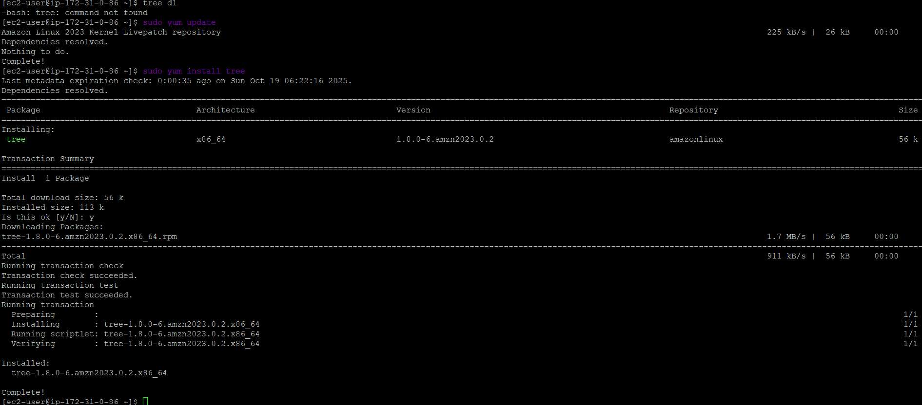
• Step1: Update YUM Repository.
• Step2: Install the Package.
• Update YUM Repository sudo YUM update.
• Install the Package sudo YUM install.
• sudo YUM install tree.
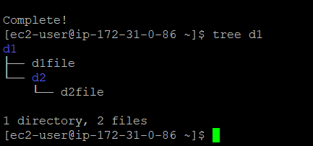
After installing sudo YUM install tree, Use the command tree <Directory_Name> we can see the directories and files in tree format.

To get the current month, we use the command cal.
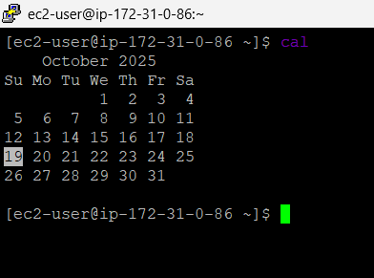

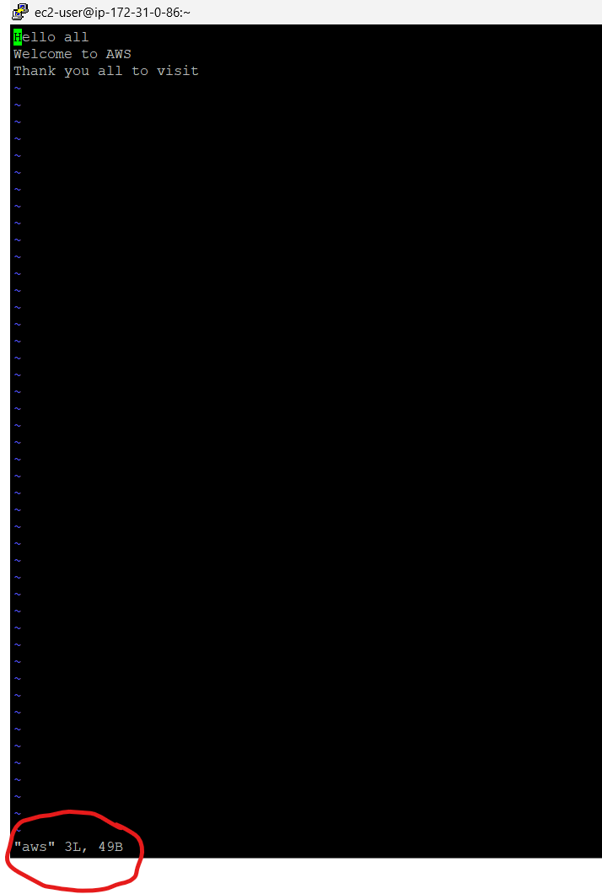 | 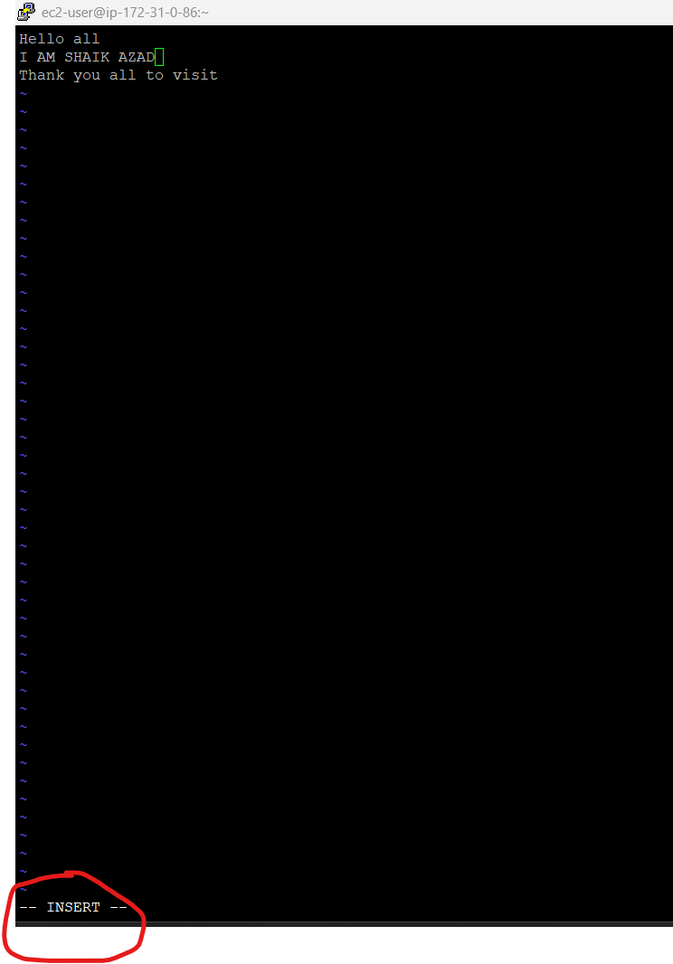
To edit the file, we use the vi <file_name> command. Whenever we are using this command, we have two modes. 1 is Command mode and 2 is Insert mode.
By default, the system will open file in command mode.
Whenever we press I, it converts into Insert mode. Above you can see the two modes.
In insert mode we can change text in the file. Above we can see the changes.
In insert mode we can’t use the mouse, just we use keyboard only for changes.
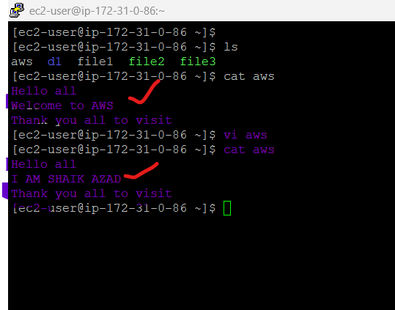 | 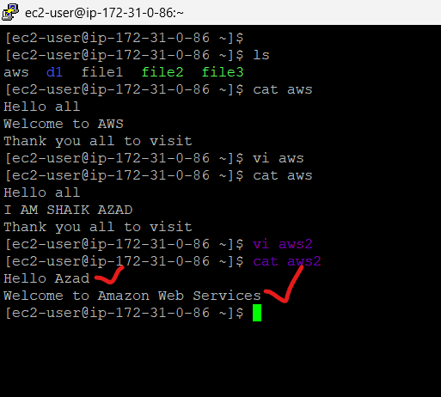

We can see the changes in file.
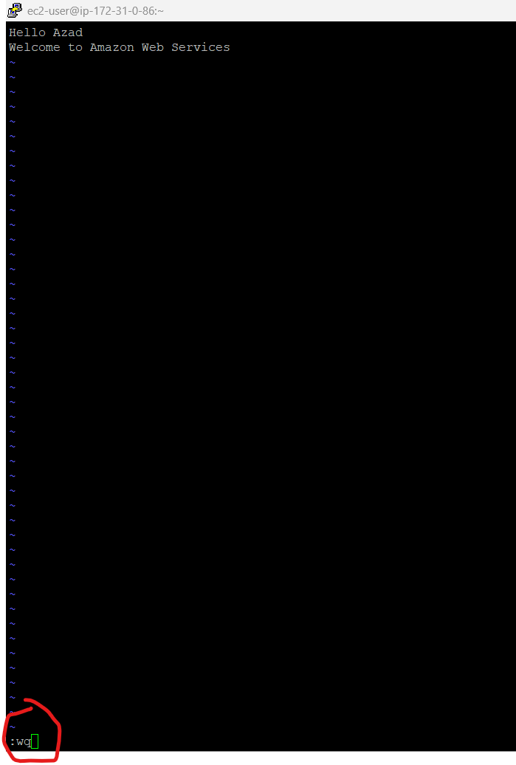
• Save the file Press Esc
• Save and exit :wq collan wq
• Exit without saving :q

DAY-4 Transfer Local Files & Elastic IP

